A Novel Measure of Educational Intergenerational Mobility: Application to a Global Dataset⋆

Khanh Duonga,∗, Wim Groota, Kristof De Wittea,b

a

UNU-MERIT, Boschstraat 24, 6211 AX, Maastricht, The Netherlands

b

Faculty of Economics and Business KU Leuven, Naamsestraat 69, 3000, Leuven, Belgium

# Abstract

Although social mobility is often associated with equality of opportunity, its precise meaning remains ambiguous. Consequently, the measurement of social mobility is problematic as well. This paper examines two key challenges in measuring social mobility: the directionality problem and the difficulty problem. The directionality problem arises when social fluidity—defined as the independence of socioeconomic outcomes from parental status—does not necessarily reflect true progress, particularly in cases of downward mobility. The difficulty problem occurs when the effort required for mobility is not properly accounted for, as it varies significantly across different social contexts. Relative mobility is often affected by the directionality problem, while absolute mobility is subject to the difficulty problem. Local measures focusing on disadvantaged groups may offer valuable insights but fail to capture the full national picture. They are also less effective in developed countries, where most of the population is already well-educated, making global comparisons more challenging. To address these issues, this paper introduces a new index called the “Progress Gap,” which quantifies the gap—interpreted as the national effort—between the actual transition matrix and a predefined target tailored to each country’s context. By design, this index is independent of country-specific factors, enabling more consistent comparisons. It offers a more rigorous and meaningful assessment of intergenerational mobility in education on a global scale, contributing to a deeper understanding of inclusive growth.

Keywords: Social mobility, Equality of opportunity, Educational progress, Measurement issues JEL: I24, D63, O15

# Introduction

“Every day, nearly 400,000 babies are born around the world. None of them get to choose their gender, race, place of birth, or the social and economic conditions of their families. Life’s starting point is a lottery. But the future needn’t be left to chance,” said Kristalina Georgieva, Chief Executive Officer of the World Bank, in their report on global intergenerational mobility (Narayan

⋆ Funding: Kristof De Witte is grateful for funding from the Horizon Europe project BRIDGE (grant 101177154). Views and opinions expressed are however those of the author(s) only and do not necessarily reflect those of the European Union or the granting authority. Neither the European Union nor the granting authority can be held responsible for them. Competing interests: The authors declare no conflicts of interest. Author contributions: KD - conceptualization, data, methods, drafting, and editing; WG - editing, review, and supervision; KDW - editing, review, and supervision.

∗

Correspondence should be addressed to Khanh Duong at duong@merit.unu.edu.

et al., 2018). All parents, but especially those in the poorest segments of society in low-income countries, hope their children will have a better life than they did. And every child in those circumstances aspires to social mobility—to break free from the constraints imposed by their birth. This idea was once called the “American Dream,” but the ideal has long transcended American borders, instilling hope in children struggling in poverty around the world. A more precise term for it is intergenerational mobility. However, a dream is just a dream when, as the World Bank report shows, upward mobility remains elusive for the poor, especially in developing countries (Narayan et al., 2018). Even in the so-called “land of opportunity,” the U.S., opportunities for social mobility are not evenly distributed, as Chetty et al. (2014) has pointed out. This raises the question: Is our current progress fair?—the very theme of the report mentioned above (Narayan et al., 2018). It also reinforces the call for equality of opportunity, as existing inequalities deepen disparities and suppress mobility, a pattern captured by what we now call the “Great Gatsby curve.”

People advocate for equality of opportunity to promote social mobility. But what does equality of opportunity truly mean? Should socioeconomic outcomes be entirely independent of parental status—as a form of freedom of choice (social fluidity)? This idea aligns with Nobel laureate Amartya Sen’s concept of development as freedom (Sen 2000). However, such freedom also requires capability. Consider the Central African Republic, where relative educational mobility—the extent to which a child’s outcome depends on their parents—is much higher than in Bhutan. Yet, their absolute mobility—the probability that a child attains a higher level of education than their parents—is nearly the same. Can we truly say the Central African Republic has better social mobility than Bhutan when much of that mobility comes from downward movement? This highlights a key limitation: social fluidity does not always result in social progress. Furthermore, there is a limit to social mobility, at some point children are no longer able to progress beyond their parents anymore. The only mobility is downward mobility and progress stagnates. This poses a challenge we term the directionality problem. Furthermore, the way absolute mobility is currently measured oversimplifies social progress by treating different efforts as equivalent, despite varying circumstances. For instance, Canada and Timor-Leste have nearly the same rate of upward mobility. However, in Timor-Leste, mobility stems from individuals in the lowest-educated groups reaching the highest levels of education, whereas in Canada, it occurs primarily within groups that are already relatively well-educated. This reflects another challenge: the difficulty problem. Together, the directionality problem and the difficulty problem call into question how intergenerational mobility is currently measured. In such comparisons, local measures focusing only on the most disadvantaged groups may provide some insights but fail to capture the full picture. Consequently, they make global comparisons difficult, especially as the engine of social mobility - i.e. which groups in societ are progressing - may differ between developed and developing countries.

To address these two problems, we develop a more comprehensive index to assess social progress in education using transition matrices. Firstly, we construct a target transition matrix representing the ideal educational progress that countries should achieve over time. The gap between actual and expected transition matrices is then measured. This approach accounts for country-specific factors, such as institutional and cultural contexts, ensuring that each country’s expected outcomes align with its initial educational distribution from the parent generation. By doing so, the measured gap reflects social progress while filtering out persistent factors like cultural norms or institutional constraints. More precisely, our index captures a country’s effort to improve social progress in education. While the expected matrices are country-specific, they follow a common underlying rule, aligning different countries to a shared reference frame for meaningful comparison. This new measure offers a more rigorous assessment of educational social progress, as it better reflects national efforts to enhance social mobility through education policies, independent of timeinvariant country-specific contexts. Consequently, this study contributes to the measurement of global sustainable development goals.

The next section (Section 2) reviews existing measures of intergenerational mobility, primarily from the World Bank, while also incorporating recent developments in the field. It concludes by highlighting the gap between the desired measurement of social progress and the challenges posed by the difficulty and directionality problems. Section 3 then details the construction of a novel approach to address this gap. This methodology is applied to the recently released global database on intergenerational mobility from the World Bank, demonstrating how our index better captures social progress compared to existing measures (see Section 4). The paper concludes with a discussion of its contributions to the field and potential directions for future research (see Section 5).

# Current measures of intergenerational mobility

Intergenerational mobility is commonly measured using three approaches (Blanden, 2013): ordinal transition matrices (education), continuous measures (earnings), and categorical measures (occupations). Earnings-based measures, such as intergenerational elasticity (IGE), provide numerical precision but are highly volatile due to career shifts, economic fluctuations and exogeneous shocks. Moreover, tracking income across generations requires reliable longitudinal data, which is often unavailable. Occupational measures, while easier to collect, lack strict hierarchical ordering and face classification inconsistencies across countries, making cross-national comparisons challenging. Educationbased transition matrices offer a more stable and structured approach. Educational attainment is widely available, less susceptible to short-term fluctuations, and provides a clear, ordered ranking that aligns with social stratification. This allows for a systematic assessment of mobility patterns across generations. Education-based measures are commonly used for global comparisons due to their reliability. While education does not fully capture quality differences or nonlinear returns to schooling, it remains one of the most robust indicators of intergenerational mobility, effectively reflecting the persistence of social status across generations.

Common measures. Intergenerational mobility in education can be assessed through two key concepts: absolute mobility and relative mobility. This study primarily adopts the World Bank’s approach (Van der Weide et al., 2024; Narayan et al., 2018) to intergenerational mobility (as shown in Table 1). Absolute mobility measures the proportion of individuals who achieve a higher education level than their parents. Two key indicators for this are CAT, which calculates the probability that a child surpasses their parents’ education level assuming the parents did not complete university, and MIX, which includes both children who exceed their parents’ education and those who reach university if at least one parent did. In contrast, relative mobility focuses on how much a child’s education is influenced by their parents’ education. The lower the dependency on parents’ education, the higher the mobility. This is often measured with statistical indicators such as 1COR, which calculates one minus the correlation between parents’ and children’s education levels, and 1-BETA, which is derived from a regression model predicting a child’s education based on their parents’ education. Both of these metrics suggest that higher values indicate greater mobility. Additionally, several measures specifically focus on mobility for children from disadvantaged backgrounds. MU050 estimates the expected education level of a child whose parents are in the bottom half of the education distribution. BHQ4 measures the likelihood that a child from a loweducation family reaches higher education levels, while AHMP tracks the percentage of children who complete primary school when neither parent has done so.

Table 1: Common measures of intergenerational mobility

|  |  |  |
| --- | --- | --- |
| Metrics | Explain | Formula |
| CAT | Pr child surpasses parent’s educational category  (conditional on parent not having tertiary) | Pr[Rc > Rp|Rp < 5] |
| MIX | Share of respondents with strictly higher educational category than parents if parents do not have tertiary, or with tertiary education if either parent has tertiary. | Pr[(Rc > Rp)∩(Rc = Rp = 5)] |
| 1-COR | 1 minus the correlation coefficient between respondents’ and parents’ years of schooling. | Cov(Y  1 − c,YP )  pVar(Yc) × Var(YP ) |
| 1-BETA | 1 minus the coefficient from regressing respondents’ years of schooling on parents’ years of schooling. | Cov(Y  1 − c,YP )  Var(YP ) |
| MU050 | Expected child educational rank from a person born in bottom half | E[Rc|Rp < Q2] |
| BHQ4 | Pr child from bottom half reaches top quartile | Pr[Rc > Q3|Rp < Q2] |
| AHMP | Share of respondents with a completed primary education conditional on neither parent having completed primary education. | Pr[Rc ≥ 2|Rp < 2] |

Notes: c denote the child and p denote the parent. The variable Y represents years of schooling, while education levels are categorized as R = {1,2,3,4,5}, corresponding to (1) less than primary, (2) primary, (3) lower secondary, (4) upper secondary, and (5) tertiary education. The second and third quartiles of the education distribution are denoted as Q2 and Q3, respectively.

Source: adapted from Van der Weide et al. (2024)

Other measures. There are additional measures beyond those mentioned above, which have been adopted by the World Bank, but they are less commonly used for comparing social progress across countries. The Prais-Bibby index (Bibby, 1975; Prais, 1955) quantifies mobility by measuring the proportion of individuals who change ranks between generations, providing a straightforward approach to assessing relative mobility. The Bartholomew index (Bartholomew, 1967) focuses on movement between ordered categories, particularly in education, calculating the weighted average distance moved between parental and children’s categories. Its standardized version offers a clearer view of upward mobility. Apouey et al. (2023) introduced an inequality-sensitive and additive achievement measure for ordinal data, which combines both average achievement and the inequality of achievement within a generation, offering a more nuanced perspective on mobility that accounts for both individual movement and societal inequality. The upward mobility kernel developed by Ray and Genicot (2023), based on the principle of growth progressivity, provides a theoretical framework for measuring upward mobility by considering individual growth rates in relation to baseline income. Finally, entropy-based measures (Mueller, 2021), derived from information theory, evaluate how much a parent’s status reduces uncertainty about a child’s future status. Higher information gain in this context suggests stronger intergenerational dependence and, consequently, higher immobility. Together, these indices and measures form a comprehensive toolkit for analyzing the complex dynamics of intergenerational mobility.

The big gap. Nevertheless, there is a gap between current measures of intergenerational mobility and what is referred to as social progress. The definition of social progress is broad, encompassing not only education and income but also health, well-being, and human rights (Narayan et al., 2018; Blanden, 2013; Deutscher and Mazumder, 2023). The focus here is not on defining social progress in its entirety but on highlighting how current measurements of social mobility do not fully capture social progress in education. While social progress in education can be closely linked to intergenerational mobility—where each generation attains better education—existing measures fail to capture true progress across countries. Consider two illustrative examples. First, a comparison between Bhutan and the Central African Republic (as shown in Figure 1) reveals that their absolute mobility, measured by the indices CAT and MIX, is nearly identical. However, the Central African Republic exhibits significantly higher relative mobility, as indicated by 1−BETA (0.53 vs. 0.21 for Bhutan). Based on this, one might conclude that the Central African Republic has achieved greater social progress than Bhutan. However, looking at their transition matrices reveals a different story. The Central African Republic has higher relative mobility primarily due to widespread downward mobility—for instance, over 35% of individuals with parents who attained at least primary education have themselves remained below the primary level (C1P2 +C1P3 > 35%). This example demonstrates that freedom of choice does not necessarily translate into progress. This issue is referred to as the directionality problem. The directionality problem is not only about distinguishing upward from downward mobility but also about considering persistence, which is less concerning than downward mobility. In Bhutan’s case, persistence is high. However, this is preferable to the higher prevalence of downward mobility seen in the Central African Republic.

The second example compares Canada and Timor-Leste, where Canada exhibits higher absolute and relative mobility. However, can one conclude that Canada has made more progress than TimorLeste? Examining their transition matrices suggests otherwise. It would be unfair to say that Timor-Leste has made less progress simply because its mobility primarily comes from disadvantaged groups, whereas mobility in Canada occurs mostly among the upper class. The effort required to achieve mobility in these two contexts is vastly different. More than a quarter of Timor-Leste’s population, whose parents had less than primary education, managed to move up to the upper secondary or tertiary level, indicating a significant achievement. In contrast, mobility in Canada mostly involves individuals moving from upper secondary to tertiary education, which represents a smaller feat in comparison. This issue is referred to as the difficulty problem, as different social classes face different levels of difficulty in achieving the same educational transition. Notably, CAT

Bhutan Central African

CAT = 0.16; 1-BETA = 0.21 CAT = 0.14; 1-BETA = 0.53

|  |  |  |  |  |  |  |  |  |  |  |
| --- | --- | --- | --- | --- | --- | --- | --- | --- | --- | --- |
| 76.71 | 8.62 | 3.08 | 0.95 | 1.05 | P1  P2  P3  P4  P5 | 31.71 | 2.83 | 3.53 | 0 | 0.27 |
| 5.17 | 1.74 | 0.76 | 0.3 | 1.12 | 11.6 | 3.46 | 2.36 | 0 | 0 |
| 0 | 0 | 0 | 0 | 0.13 | 15.64 | 5.45 | 6.17 | 0.22 | 1.58 |
| 0.04 | 0.05 | 0.06 | 0.03 | 0.2 | 1.23 | 0.3 | 1.69 | 1.26 | 1.8 |
| 0 | 0 | 0 | 0 | 0 | 0.93 | 0.76 | 3.41 | 0 | 3.8 |

P1

P2

P3

P4

P5

C1 C2 C3 C4 C5 C1 C2 C3 C4 C5

Figure 1: Absolute Mobility Comparison

Notes: CAT measures absolute mobility, 1-BETA measures relative mobility. The data is sourced from the Global Database on Intergenerational Mobility (2023). The analysis focuses on the 1980 cohort, comparing the education levels of all children to the maximum education level of their parents.

does not account for individuals whose parents had tertiary education, and MIX treats cases where both parents and children attain the highest education level (C5P5) as upward mobility due to ceiling effects.

Canada Timor-Leste

CAT = 0.69; 1-BETA = 0.74 CAT = 0.62; 1-BETA = 0.42

|  |  |  |  |  |  |  |  |  |  |  |
| --- | --- | --- | --- | --- | --- | --- | --- | --- | --- | --- |
| 0 | 0 | 0 | 0 | 0 | P1  P2  P3  P4  P5 | 34.03 | 16.62 | 11.73 | 19.63 | 7.35 |
| 0 | 0 | 0.4 | 0.8 | 1.3 | 1.09 | 0.4 | 0.95 | 2.19 | 0.79 |
| 0 | 0 | 0.3 | 1.41 | 2.19 | 0.14 | 0.27 | 0.1 | 1.14 | 0.69 |
| 0 | 0 | 1.27 | 9.19 | 17.71 | 0.15 | 0.01 | 0.51 | 1.22 | 0.52 |
| 0 | 0 | 0.83 | 12.24 | 52.37 | 0.01 | 0 | 0 | 0.26 | 0.19 |

P1

P2

P3

P4

P5

C1 C2 C3 C4 C5 C1 C2 C3 C4 C5

Figure 2: Relative Mobility Comparison

Notes: CAT measures absolute mobility, 1-BETA measures relative mobility. The data is sourced from the Global Database on Intergenerational Mobility (2023). The analysis focuses on the 1980 cohort, comparing the education levels of all children to the maximum education level of their parents.

In summary, current measures of intergenerational mobility are inadequate for assessing social progress in education. They also do not allow for a straightforward comparison between countries. Although local measures can be helpful, they cannot capture a comprehensive picture of social progress. Therefore, we developed a more comprehensive index to evaluate the social progress of education using transition matrices. This approach functions like a dimensionality reduction method that condenses information into a single uni-dimensional measure. However, this measure provides far more insight into social progress than a standard factor analysis. The proposed methodology directly addresses the difficulty and directionality problems outlined above.

In the following section, a target transition matrix is constructed to represent the ideal educational progress countries should achieve over time. The gap between the actual and expected transition matrices is then measured. This method accounts for country-specific backgrounds (such as institutional and cultural factors), ensuring that each country’s expected outcomes align with its initial educational distribution from the parent generation. By doing so, the gap reflects social progress while eliminating differences that are relatively stable over time, such as cultural norms or institutional constraints. More precisely, our index measures the country’s effort to obtain social progress in terms of education. Importantly, while the expected matrices are country-specific, they follow a common underlying rule—similar to aligning different countries to a shared reference frame for meaningful comparison.

# New measurement of social progress

As discussed in the previous section, we define the expected transitions matrix to compute the gap between the actual matrix and the expected one, measuring the social progress gap via education. An expected transitions matrix must address both the difficulty and directionality problems while remaining country-specific to eliminate unobserved fixed effects such as culture and institutions. Therefore, we start with the original education distribution of the parent generation, where P1 is the probability of a parent having education level 1, P2 for level 2, P3 for level 3, P4 for level 4, and P5 for level 5. Our goal is to establish the destination education distribution of the child generation while preserving the original distribution. In other words, the row sums of the expected matrix at each parent education level must equal those of the actual matrix:

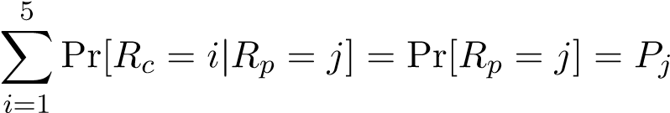. (1)

The directionality problem. To address the directionality problem, we divide the expected matrix into three areas: downward, persistent, and upward. Since the expected matrix reflects the desired pattern of social mobility, the downward area should be zero (as there is no social progress involved in downward mobility), the persistent area should be minimized (but remain greater than zero, as it is not as undesirable as downward mobility and is an inevitable part of intergenerational mobility), and the remaining probabilities should be allocated to the upward region. There are two major issues to resolve here. First, we must determine the minimum extent of the intergenerational transmission. As discussed earlier regarding the ceiling effect, when parents have the highest education level, their children have no possible space for upward mobility. Therefore, this case cannot be treated the same as other persistent cases. In the expected matrix, children should retain their parents’ highest education level, meaning

Pr[Rc = 5|Rp = 5] = Pr[Rp = 5] = P5.

For other cases in the persistent area, we assume an intergenerational transmission effect of education, acknowledging that parenting itself is a form of education. However, we reject the notion that the genetic lottery hinders equality of opportunity. Based on evidence on the causal effect of intergenerational transmission (which isolates genetic transmission from education attainment), we assume a true intergenerational effect of ω = 0.1 following Holmlund et al. (2011). This implies that there is a 10% probability that children remain at the same education level as their parents:

Pr[Rc = i|Rp = i] = ω Pr[Rp = i], ∀ i < 5.

We recognize that our method is sensitive to the choice of ω. To assess robustness, we conducted an additional calculation with ω = 0.15, following Fleury and Gilles (2018), and found that the results remain stable (see Appendix B). One could argue for using BETA values from each country or the mean of BETA across countries as persistent probabilities instead of our approach. However, using country-specific BETA values would not produce a comparable index. In countries with high actual persistence, such as Bhutan, the difference between the expected and actual matrices would be small, making it impossible to conclude whether Bhutan is progressive. While the mean BETA across countries might better measure progress, it does not address the problem of the genetic lottery, which is a barrier to equality of opportunity. Moreover, BETA is derived from actual values, whereas an expected matrix should be defined independently of actual values to properly measure progress. Therefore, setting a fixed intergenerational effect makes more sense as a shared reference frame. However, it remains subject to the original circumstances of each country since the persistent value is determined by the product of ω and the original education distribution of the parent generation.

The difficulty problem. The second major challenge is determining how to distribute the remaining probabilities into the upward area while adhering to the difficulty rule. For children who have attained the same education level, those from disadvantaged backgrounds (lower parent education) face additional challenges, this means lower probabilities. To address this, we apply the law of total probability, which states that:

Pr(A | D) = Pr(A | B,D) × Pr(B | D) + Pr(A | Bc,D) × Pr(Bc | D),

where Bc represents the complement of B, i.e., the event in which B does not occur. This formulation divides event A into two mutually exclusive scenarios: one in which B occurs and one in which it does not. In the context of intergenerational mobility, let A represent the event that a child reaches education level z, denoted as A = {Rc = z}. Let B be the event that the child first reaches an intermediate education level j, written as B = {Rc = j}, and let D represent the conditioning event where the parent has education level i, expressed as D = {Rp = i}, with the assumption that i < j < z. Using this framework, the probability that a child attains education level z, given that the parent has level i, is:

Pr(Rc = z | Rp = i) = Pr(Rc = z | Rc = j,Rp = i) × Pr(Rc = j | Rp = i)

(2)

+ Pr(Rc = z | Rc ̸= j,Rp = i) × Pr(Rc ≠ j | Rp = i).

Since the education levels follow an ordinal structure, meaning a child must pass through level j before reaching z, the probability of skipping levels is zero:

Pr(Rc = z | Rc ̸= j,Rp = i) = 0.

This simplifies equation (2) to:

Pr(Rc = z | Rp = i) = Pr(Rc = z | Rc = j,Rp = i) × Pr(Rc = j | Rp = i). (3)

To further simplify, we assume that:

Pr(C = z | C = j,P = i) = Pr(C = z | P = j).

This assumption implies that the condition (Rc = j,Rp = i) is equivalent to (Rp = j), meaning that the family background is identical in the following two cases: (1) the sibling’s education level is j, and (2) the parent has education level j. Thus, equation (3) can be rewritten as:

Pr(Rc = z | Rp = i) = Pr(Rc = z | Rp = j) × Pr(Rc = j | Rp = i).

To operationalize this, let a, b, c, and d represent the probabilities of transitioning from one education level to the next, specifically: a = Pr(Rc = 2 | Rp = 1), b = Pr(Rc = 3 | Rp = 2), c = Pr(Rc = 4 | Rp = 3), and d = Pr(Rc = 5 | Rp = 4). Using these definitions, we express the expected transition matrix (see Table 2) as follows:

Table 2: The expected matrix

|  |  |  |  |  |  |  |
| --- | --- | --- | --- | --- | --- | --- |
|  | C1 | C2 | C3 | C4 | C5 | Total |
| P1 | ω × P1 | a | a × b | a × b × c | a × b × c × d | P1 |
| P2 | 0 | ω × P2 | b | b × c | b × c × d | P2 |
| P3 | 0 | 0 | ω × P3 | c | c × d | P3 |
| P4 | 0 | 0 | 0 | ω × P4 | d | P4 |
| P5 | 0 | 0 | 0 | 0 | P5 | P5 |
|  |  |  |  |  |  | 100% |

Applying the law of total probability to this structure, the constraints on the transition probabilities can be written as:



ba++ba××cb++ba××cb××dc= (1+ a ×−bω×)Pc2×<d1= (1, − ω)P1 < 1,

dc += (1c ×−dω= (1)P4 −<ω1.)P3 < 1,

Solving for a, b, c, and d, we get:

(4)

,

As shown in equation (4), all transition probabilities are less than one, meaning the allocation of probabilities into the upward area remains valid. To illustrate the expected transition matrix (see 3), we compare the cases of Vietnam and the United States. The left-side charts show the actual transition matrices, while the right-side charts display the expected matrices.

Vietnam (Actual) Vietnam (Expected)

|  |  |  |  |  |  |  |  |  |  |  |
| --- | --- | --- | --- | --- | --- | --- | --- | --- | --- | --- |
| 1.02 | 2.78 | 1.57 | 2.61 | 0.93 | P1  P2  P3  P4  P5 | 0.89 | 6.88 | 0.93 | 0.16 | 0.05 |
| 0.67 | 3.14 | 4.2 | 4.48 | 5.84 | 0 | 1.83 | 13.54 | 2.27 | 0.68 |
| 0 | 2.05 | 4.16 | 9.49 | 8.52 | 0 | 0 | 2.42 | 16.77 | 5.02 |
| 0 | 1.3 | 3.35 | 9.5 | 19.12 | 0 | 0 | 0 | 3.33 | 29.94 |
| 0 | 0.09 | 0.16 | 2.42 | 12.6 | 0 | 0 | 0 | 0 | 12.6 |

P1

P2

P3

P4

P5

C1 C2 C3 C4 C5 C1 C2 C3 C4 C5

United States (Actual) United States (Expected)

|  |  |  |  |  |  |  |  |  |  |  |
| --- | --- | --- | --- | --- | --- | --- | --- | --- | --- | --- |
| 0 | 0.02 | 0.1 | 0.75 | 0.45 | P1  P2  P3  P4  P5 | 0.13 | 1.17 | 0.03 | 0 | 0 |
| 0 | 0.06 | 0.28 | 1.49 | 0.75 | 0 | 0.26 | 2.25 | 0.05 | 0.02 |
| 0 | 0.13 | 0.32 | 1.69 | 0.93 | 0 | 0 | 0.31 | 2.02 | 0.74 |
| 0 | 0.26 | 3.09 | 23.24 | 14.03 | 0 | 0 | 0 | 4.06 | 36.55 |
| 0 | 0 | 0.81 | 14.28 | 37.34 | 0 | 0 | 0 | 0 | 37.34 |

P1

P2

P3

P4

P5

C1 C2 C3 C4 C5 C1 C2 C3 C4 C5

Figure 3: The expected matrices for Vietnam and The US

The progress gap. To calculate the progress gap between the actual Q(x) and expected P(x) matrices, f-divergences are utilized, which commonly include KL-divergence (Csisz´ar, 1975), Hellinger distance (Jeffreys, 1946), and total variation distance (Chatterjee, 2008). The KL-divergence is defined as

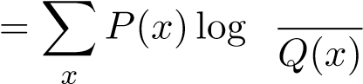ïP(x)ò

DKL.

However, because P(x) and Q(x) can be zero or approaching zero, the KL-divergence can yield extremely high values, which may not always be desirable. In contrast, the Hellinger distance provides a more robust measure, defined as

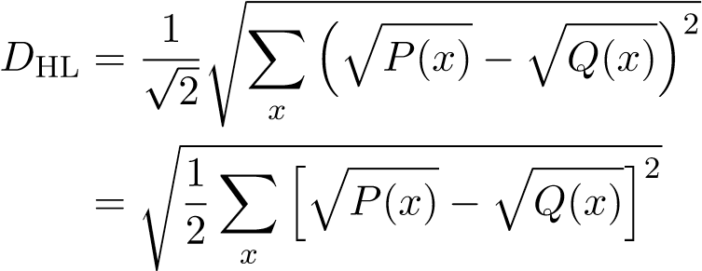.

This formulation captures the differences between distributions without the issues associated with zero probabilities. Finally, the total variation distance is given by

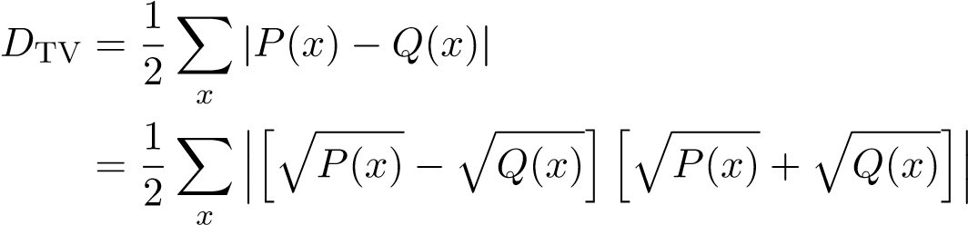.

While total variation distance is another common measure, it is affected by the term îpP(x) + pQ(x)ó, making it less sensitive to small differences compared to the Hellinger distance. As a result, the Hellinger distance is considered a more effective way to capture the gap between the actual and expected distributions.

Based on the Hellinger distance, we develop the Progress Gap as a measure of social progress to calculate the distance between the actual matrix and the expected matrix. The Progress Gap DPG is defined as:

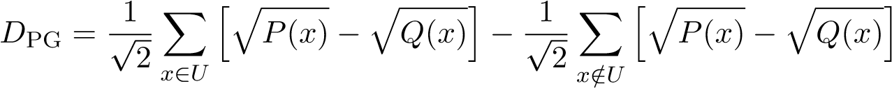 ,

where U is the set of probabilities in the upward area, defined as U = {(c,p) | 1 ≤ c < p ≤ 5} ∪ {(5,5)}, with c representing the child’s education level and p representing the maximum

parent’s education level. Unlike the Hellinger distance, which uses the absolute value p[f(x)]2 to measure the distance, we adjust the signs to fit the definition of social progress. Specifically, downward and persistent mobility are considered “bad” signs, while upward mobility is seen as a “good” sign. Since the expected value can be exceeded if a country implements effective radical

education policies, resulting in îpP(x) − pQ(x)ó < 0, this exceptional achievement is deducted from the progress gap, making the gap smaller. Because our progress gap index can be negative, exceeding the range of [0,1], we apply a max-min normalization to facilitate comparisons with both absolute and relative mobility:

DPG|norm 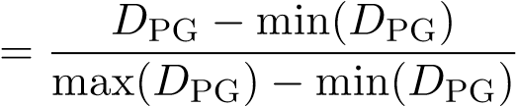.

Since the goal of this research is to compare social progress among countries, normalization makes sense as it provides a relative measure, rather than an absolute one, which is more sensitive to predefined assumptions. To ensure robustness, our methods should be applied consistently across countries, using the same settings. This includes analyzing the same cohorts and employing the same comparison methods. Specifically, we recommend using the maximum education level of both parents versus the education level of the child, which has been considered the most reliable approach (Van der Weide et al., 2024). By maintaining these consistent criteria across different countries, we can better ensure that the progress gap measurement reflects meaningful and comparable social progress, minimizing potential biases that could arise from differing methods or population characteristics. This consistency is crucial for drawing valid comparisons and understanding the social mobility across countries.

# Application to a new global dataset

We apply our method to the Global Database on Intergenerational Mobility (GDIM), which consolidates data from over 400 household surveys, providing a comprehensive analysis of intergenerational mobility in education across 153 countries, representing about 97 percent of the global population, with the latest cohort from the 1980s. The unit of analysis represents each survey, including details such as the country, cohorts of respondents, survey year, methods for calculating parents’ education (Mother/Father/Average/Max), methods for calculating children’s education (Sons/Daughters/All), the number of observations, and key indicators such as the share of parents with different education levels, the share of children with different education levels, and measures of intergenerational mobility for that survey. Each survey has many metrics, including but not limited to: CAT, which measures the probability that a child surpasses the parent’s educational category (conditional on the parent not having tertiary education); MIX, which measures the probability of a child surpassing the parent’s educational category while considering children with tertiary education as mobile; CAT ISCED0 (equivalent to AHMP), which tracks the probability of a child surpassing the parent’s educational category when parents have less than primary education; COR, the correlation coefficient between the children’s and parents’ years of schooling; BETA, the beta coefficient from regressing children’s years of schooling on parents’ years of schooling; MU050, the expected educational rank of a child born in the bottom half; BHQ4, the probability that a child from the bottom half reaches the top quartile; and the Transition Matrix.

This study focuses on evaluating absolute mobility, measured by CAT, and relative mobility, measured by 1-BETA. While local measures such as AHMP, MU050, and BHQ4 can be useful for assessing inequality among disadvantaged groups, they do not adequately capture social mobility at the societal level. Regarding absolute mobility, CAT is more closely aligned with our index than MIX. Although both measure upward mobility, they differ in how they account for the ceiling effect. CAT ignores the ceiling effect by treating it as a form of intergenerational persistence, whereas MIX considers it a type of upward mobility. In our approach, the ceiling effect is viewed as both persistent and upward. Specifically, in our expected matrix, the probability that a child with the highest-educated parents attains the highest education level should remain stable across generations, a form of intergenerational persistence. The conditional probability is 1 always. It is only stabel between two generations, parents and children as there is inflow through social mobility jn the next generation

However, upward mobility is still present because, for other lower education levels, only 10% of individuals should retain their parents’ education level, implying that 90% should experience upward mobility. In cases of ceiling upward mobility, individuals reach the highest education level, just like their parents. For relative mobility, we agree with Van der Weide et al. (2024) that 1-BETA better represents relative mobility compared to 1-COR, as BETA is not influenced by education inequality at the child generation Var(Yc). In summary, this study will compare different measures of intergenerational mobility, focusing on CAT, 1-BETA, and our proposed index.

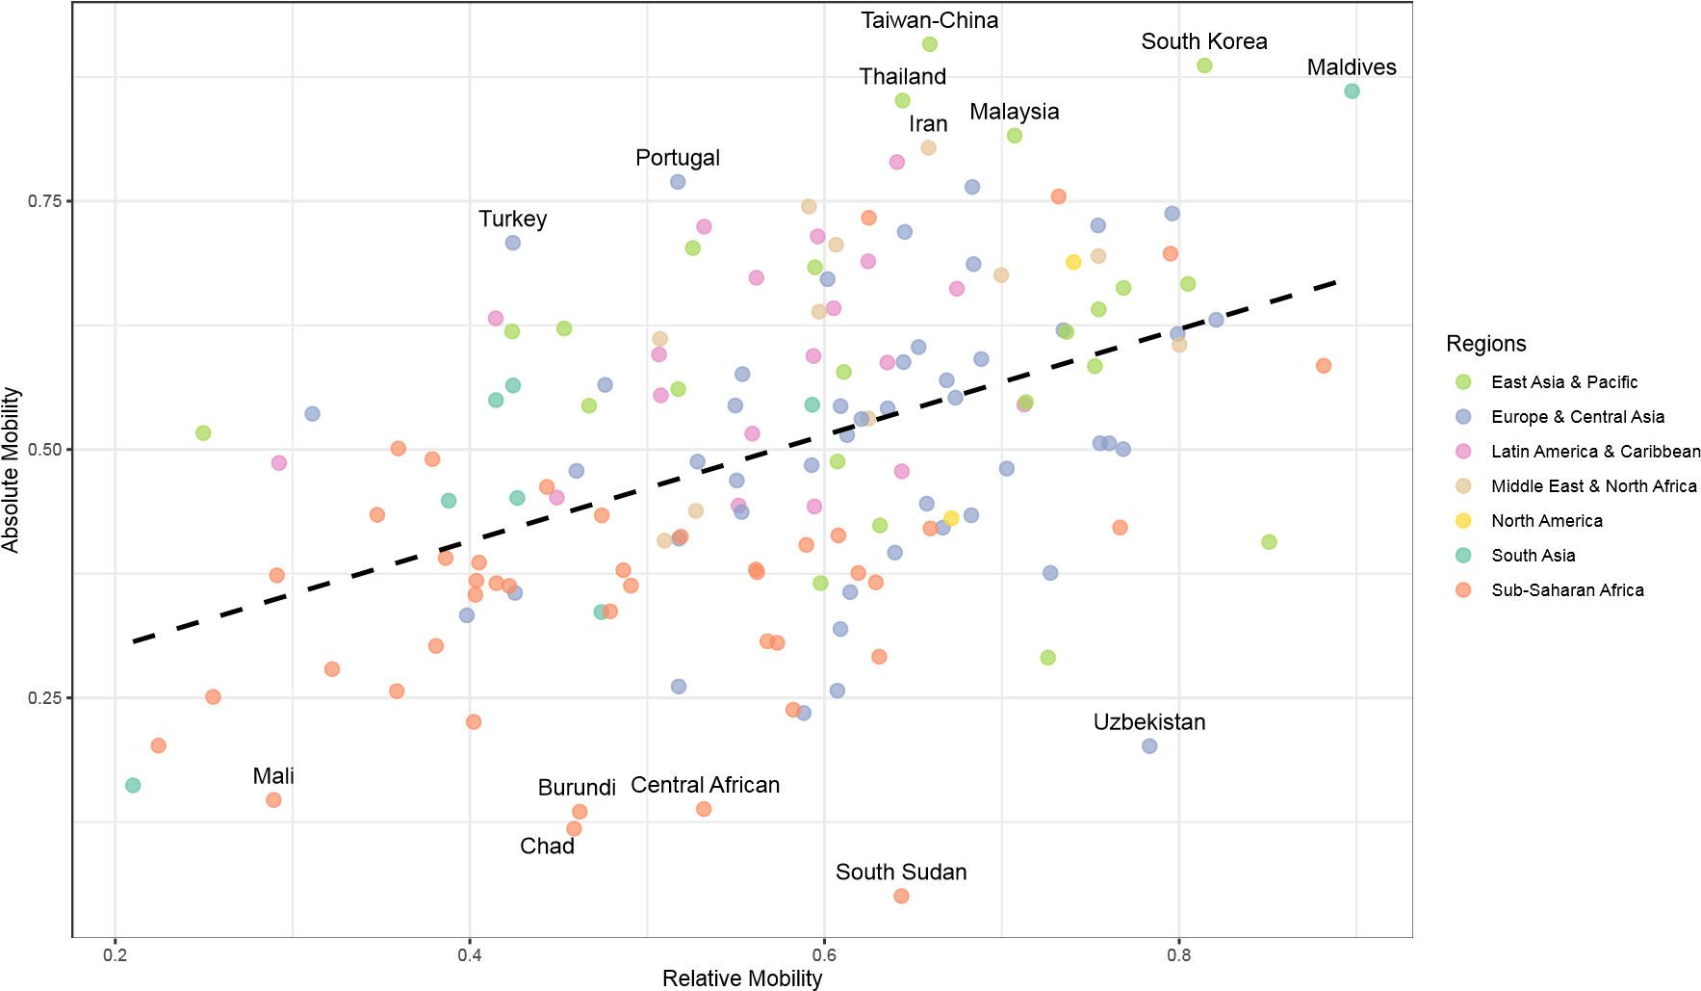

Figure 4: Absolute and Relative

To compare with the mobility indexes reported in the World Bank’s analysis using GDIM, the data is filtered by selecting parents’ education as the maximum level (the most robust measure), children’s education as all (gender-neutral), and the 1980s cohort (the latest available). Absolute and relative mobility in GDIM are presented in Figure 4. There is a significant gap in interpretation between absolute mobility (CAT, which captures upward trends) and relative mobility (1-BETA, which reflects freedom of choice). For example, in the case of South Sudan, relative mobility is relatively high, comparable to upper-middle-income countries like Thailand and Malaysia. However, South Sudan has the lowest absolute mobility, whereas Thailand and Malaysia rank among the highest in absolute mobility. While Van der Weide et al. (2024) “refrain from using the terms absolute and relative,” treating them interchangeably under the single term “social mobility” should be reconsidered. Measures of absolute mobility, such as CAT and MIX, are often categorized as social mobility, but in reality, they assess social progress (albeit imperfectly) with a focus on upward trends. In contrast, measures of relative mobility, such as 1-COR and 1-BETA, are also framed as social mobility, but they actually capture social fluidity, which aligns more closely with concepts like entropy and freedom of choice. While both social progress and social fluidity can be interpreted in terms of equality of opportunity, social progress is inherently directional.

New global rankings. From GDIM, we calculate the progress gap as outlined in Section 3. The data cleaning process ensures that each transition matrix sums to 1, as the original GDIM data is set such that the total share of all children with the same family background equals 1, P5i=1 Pr[Rc = i|Rp] = 1. Figure 5 visually ranks countries based on our progress gap index and groups them into three equal-sized categories. Each bar represents a country, colored according to its region, allowing for regional comparisons of progress. The chart also includes three key mobility measures represented by different symbols: absolute mobility CAT (blue squares), relative mobility 1-BETA (red circles), and a progressive measure MIX (green triangles). The full details are shown in the Appendix A. According to our progress gap index, South Korea and Taiwan are the most progressive economies, linked to their exceptional economic development (Morris, 1996), while the Central African Republic and Zambia rank the lowest. To provide a clearer regional distribution, we present the progress gap index on a global map. The results indicate that Africa and South Asia are less progressive, whereas most developed countries show higher progressiveness. Interestingly, Latin America demonstrates progress in education, but this does not translate into economic development. This can be explained by the mismatch between education and labor market outcomes in the region, as discussed by Bassi et al. (2012).

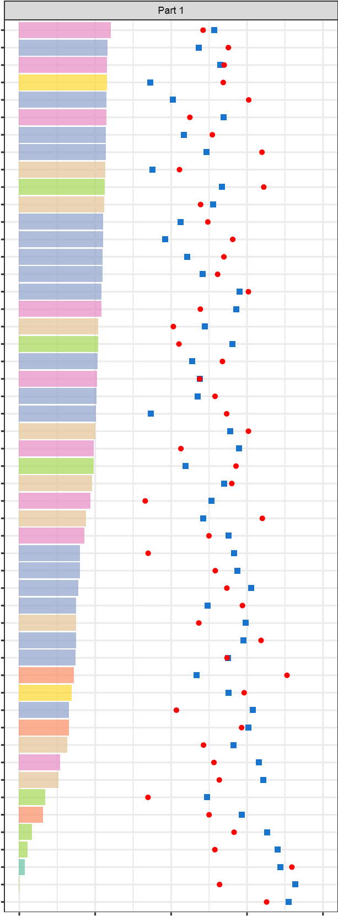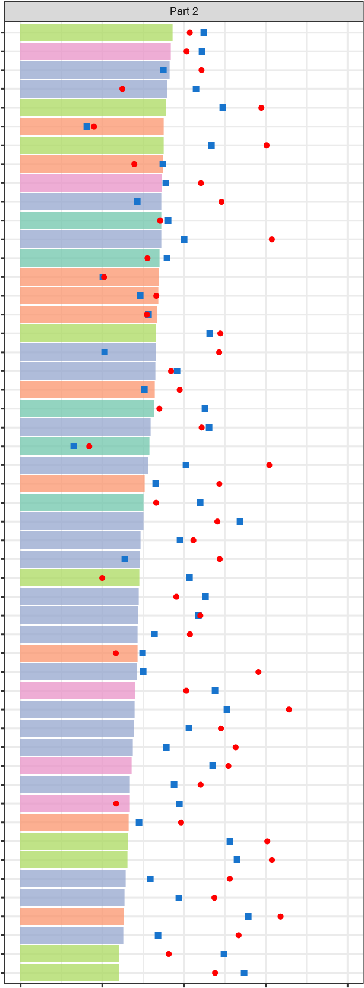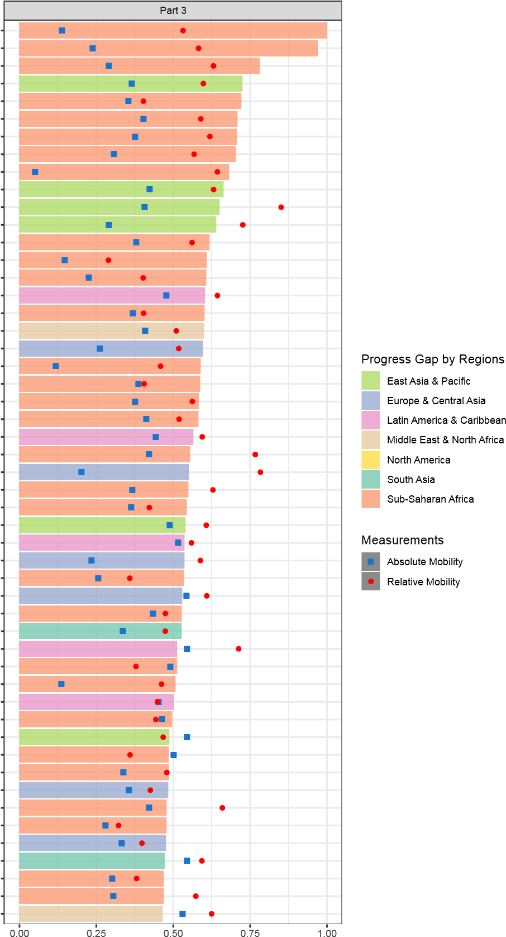PeruChinaCentral African

BelgiumPanamaZambia

VenezuelaSerbiaLiberia

United StatesRomaniaVanuatu

FinlandKiribatiCongo-Brazzaville

BoliviaBurkina FasoGabon

SloveniaTuvaluEswatini

DenmarkMadagascarTanzania

DjiboutiEl SalvadorSouth Sudan

New ZealandEstoniaPapua New Guinea

TunisiaPakistanPhilippines

UkraineTajikistanTonga

LithuaniaNepalUganda

NorwayBeninMali

PolandMozambiqueSenegal

NetherlandsSierra LeoneCosta Rica

MexicoFijiCameroon

MoroccoCzech RepublicIraq

VietnamMontenegroArmenia

ItalyRwandaChad

ParaguayIndiaIvory Coast

SwedenBosniaNamibia

BelarusBhutanCongo-Kinshasa

JordanIcelandNicaragua

ColombiaComorosSao Tome and Principe

JapanBangladeshUzbekistan

YemenAlbaniaMalawi

HaitiMoldovaTogo

15

IsraelSlovakiaLaos

ChileMyanmarUruguay

TurkeyMacedoniaAzerbaijan

IrelandCroatiaGuinea-Bissau

SpainAustriaKosovo

FranceSudanGhana

LebanonGermanyAfghanistan

CyprusEcuadorDominicana

GreeceUnited KingdomLesotho

MauritiusLatviaBurundi

CanadaSwitzerlandHonduras

PortugalArgentinaNigeria

BotswanaGeorgiaSolomons

EgyptGuatemalaAngola

BrazilGambiaNiger

IranMongoliaBulgaria

Timor-LesteAustraliaKenya

Cabo VerdeKyrgyzstanEthiopia

MalaysiaRussiaHungary

ThailandSouth AfricaSri Lanka

MaldivesKazakhstanGuinea

Taiwan-ChinaCambodiaMauritania

South KoreaIndonesiaPalestine

0.00 0.25 0.50 0.75 1.00 0.00 0.25 0.50 0.75 1.00 0.00

Figure 5: Global Rankings by Progress Gap

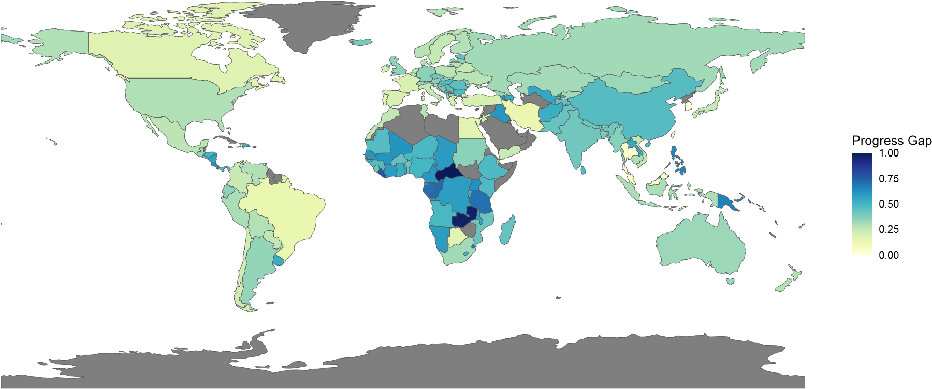

Figure 6: Global mobility by a new measurement

One of the potentially controversial cases in our proposed index is Bhutan and Iceland, which appear next to each other in the ranking of the progress gap. To clarify this, we present their transition matrices in Figure 7. It is evident that Bhutan lags significantly behind Iceland in both absolute mobility (0.16 vs. 0.51) and relative mobility (0.21 vs. 0.76). Additionally, Iceland’s education distribution is far better than Bhutan’s, as most of Iceland’s population is highly educated, whereas the majority of Bhutan’s population has not attained even primary education. There is ample evidence to conclude that Iceland is much more progressive than Bhutan. However, this overlooks the difficulty problem when discussing equality of opportunity. Iceland’s initial conditions were significantly better than Bhutan’s, so a simple comparison based on education distribution alone is insufficient. Our measure, as its name suggests, captures the progress gap, meaning it evaluates a country’s success to improve rather than its current status. This case also illustrates a fundamental conflict between the concepts of social progress and social fluidity when both are used to assess equality of opportunity. Specifically, while we do not deny that Iceland likely provides greater freedom of education choice than Bhutan (as reflected in higher relative mobility), such freedom does not necessarily translate into social progress. As Figure 7 shows, Iceland’s downward mobility rate is just as high as its upward mobility rate. In summary, in terms of social progress, Bhutan and Iceland are nearly identical, despite their significant differences in social fluidity.

Bhutan Iceland

CAT = 0.16; 1-BETA = 0.21 CAT = 0.51; 1-BETA = 0.76

|  |  |  |  |  |  |  |  |  |  |  |
| --- | --- | --- | --- | --- | --- | --- | --- | --- | --- | --- |
| 76.71 | 8.62 | 3.08 | 0.95 | 1.05 | P1  P2  P3  P4  P5 | 0 | 0 | 0 | 0 | 0 |
| 5.17 | 1.74 | 0.76 | 0.3 | 1.12 | 0 | 0 | 0 | 0.32 | 0 |
| 0 | 0 | 0 | 0 | 0.13 | 0.58 | 0 | 3.64 | 5.74 | 6.67 |
| 0.04 | 0.05 | 0.06 | 0.03 | 0.2 | 0 | 0 | 8.47 | 13.91 | 14.54 |
| 0 | 0 | 0 | 0 | 0 | 0 | 0 | 3.84 | 13.45 | 28.84 |

P1

P2

P3

P4

P5

C1 C2 C3 C4 C5 C1 C2 C3 C4 C5

Figure 7: Bhutan vs. Iceland

Notes: CAT measures absolute mobility, 1-BETA measures relative mobility. The data is sourced from the Global Database on Intergenerational Mobility (2023). The analysis focuses on the 1980 cohort, comparing the education levels of all children to the maximum education level of their parents.

Comparison to current measures. Finally, we examine the relationship between our new index, absolute mobility, and relative mobility using linear relationships in Figures 8 and 9. Our index closely aligns with absolute mobility in capturing social progress and shows minimal outliers. However, while both measure social progress, our index is more advanced as it addresses the directionality problem. Due to this limitation, absolute mobility fails to differentiate between countries experiencing a downward trend, such as the Central African Republic and Zambia, and those with more persistent trends, such as Burundi, Bhutan, and Burkina Faso. Compared to relative mobility, our index highlights significant differences stemming from the fundamental distinction between social fluidity and social progress, as discussed earlier. For instance, both Timor-Leste (Figure 1) and the Central African Republic (Figure 2) exhibit high relative mobility. However, Timor-Leste’s mobility is upward, whereas the Central African Republic’s is downward. Regarding the difficulty problem, Figures 2 (current measures) and 5 (our index) illustrate the case of Canada and TimorLeste. Under our framework, Timor-Leste appears more progressive than Canada because it has had greater succes in achieving social progress, even though Canada has a much higher level of education. In this case, we also account for the ceiling effect. In summary, our index provides a more robust measure of social mobility than existing metrics.

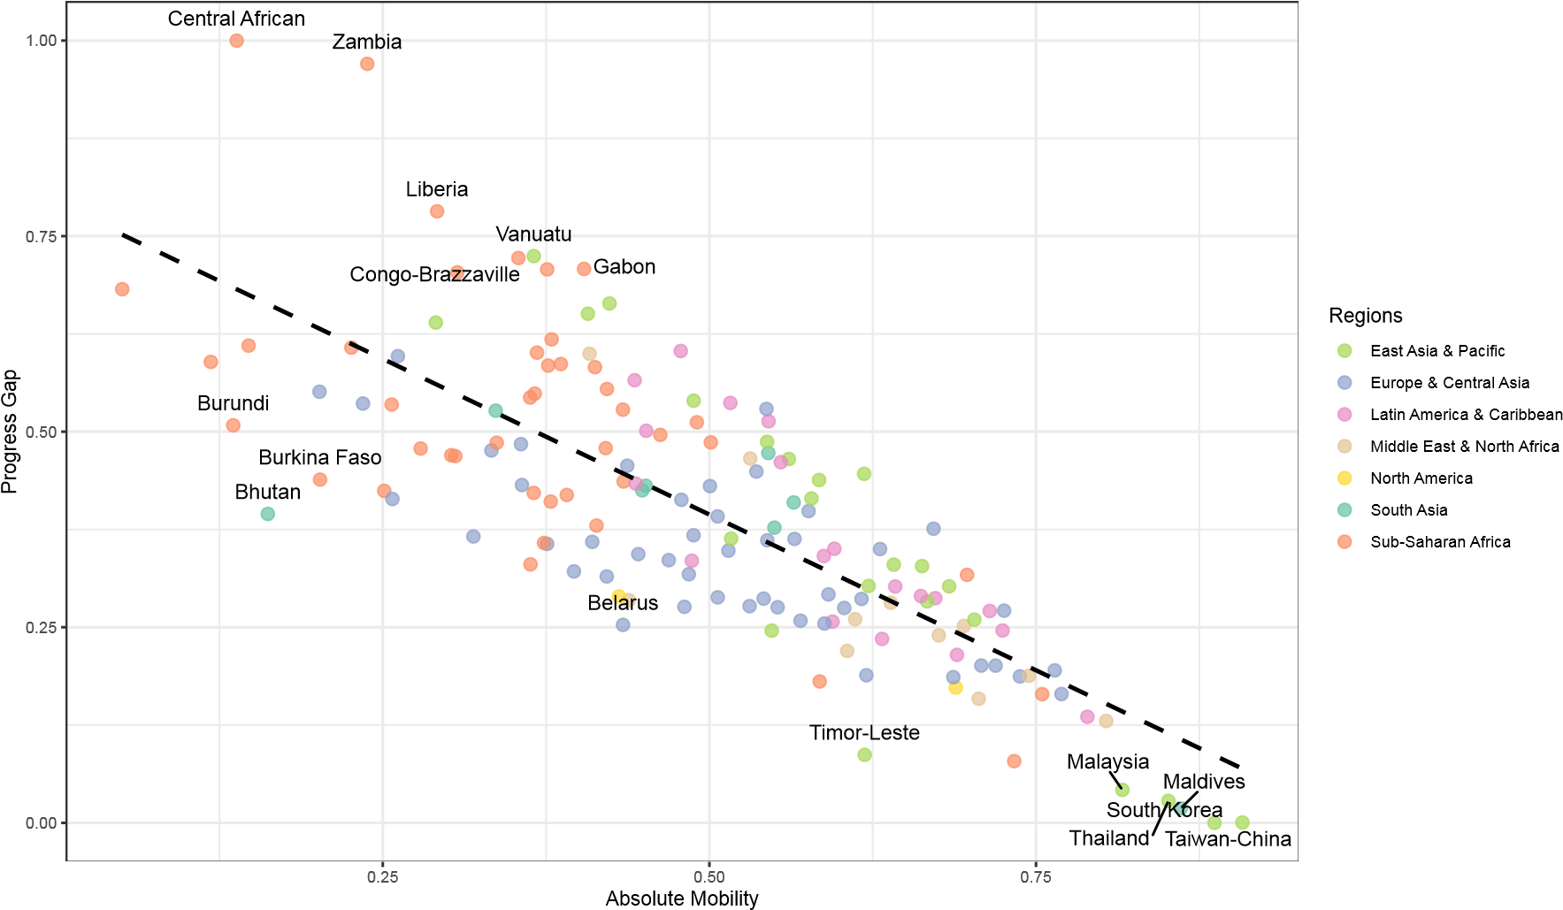

Figure 8: Compared to absolute mobility

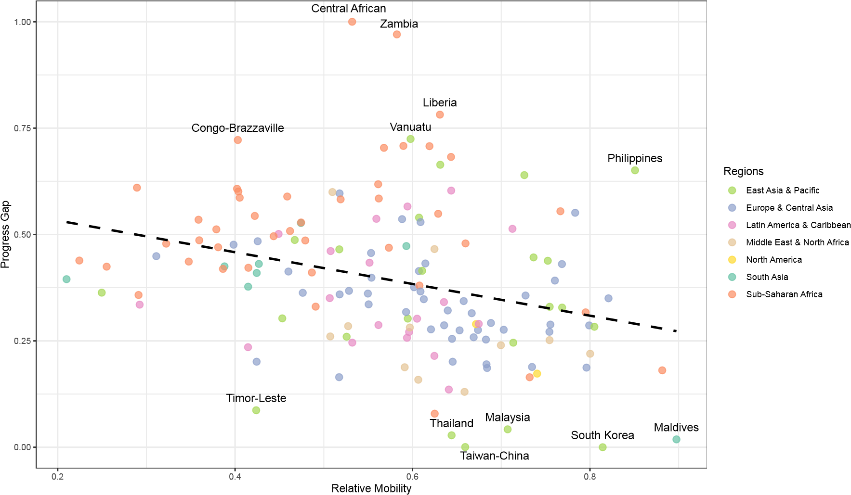

Figure 9: Compared to relative mobility

# Conclusion

Current measures of intergenerational mobility fail to fully capture social progress in education. For instance, while Bhutan and the Central African Republic show similar levels of absolute mobility, the Central African Republic’s higher relative mobility is largely driven by widespread downward mobility, which does not reflect true progress. Similarly, although Canada and TimorLeste exhibit different mobility levels, the effort required for mobility in Timor-Leste is much greater, suggesting a different form of progress. To address these issues, this study develops a new index based on transition matrices, offering a more rigorous measure of educational social progress. By constructing an expected transition matrix that accounts for country-specific factors, this approach isolates genuine progress while filtering out persistent institutional and cultural constraints. The resulting measure aligns countries to a common reference frame, allowing for more meaningful comparisons of national efforts to advance social mobility through education. Our progress gap index, calculated using data from the GDIM, provides a clearer assessment. It shows that South Korea and Taiwan are the most progressive in terms of educational mobility, while countries like the Central African Republic and Zambia rank the lowest. Regional trends reveal that Africa and South Asia are less progressive in social mobility, while most developed countries show higher progress. In contrast, Latin America demonstrates educational progress, but this does not translate into economic development. This may be due to exogenous factors like including a mismatch between education and labor market outcomes.

Although our method is based on the World Bank’s approach and reports, the scope of this study extends beyond the confines of this study. The current measures we review are not exclusive to the World Bank; they are widely used in the field of intergenerational mobility (Corak, 2020; Chetty et al., 2014; Asher et al., 2019; Alesina et al., 2021; Chetty et al., 2017). To clarify, we are not studying a unique measurement used by one organization for its own report, but rather evaluating common measures in the field that have been compiled and applied by the World Bank in its recent database release. Moreover, our method can be extended to other ordinal measurements using mobility tables, such as self-reported health (Halliday et al., 2021) or well-being (Molina et al., 2011). However, this would require further research and testing. One limitation of our method is its sensitivity to the selection of the true effect of intergenerational mobility, as some studies may report the effect as slightly larger - that is ω = 0.15, as shown by Fleury and Gilles (2018). Nonetheless, this does not significantly change the overall findings of our study (see Appendix B).

Supplementary material

An online appendix for this article is available on the journal’s website.

# Data availability

The data and code supporting the findings of this study are available at https://github.com/ duongkhanhk29/MEASURE_MOBILITY/.

# References

Alesina, A., Hohmann, S., Michalopoulos, S., Papaioannou, E., 2021. Intergenerational mobility in africa. Econometrica 89, 1–35.

Apouey, B., Nissanov, Z., Silber, J., 2023. Ordinal variables and the measurement of upward and downward intergenerational educational mobility in european countries. Review of Income and Wealth 69, 776–800.

Asher, S., Novosad, P., Rafkin, C., 2019. Getting signal from interval data: Theory and applications to mortality and intergenerational mobility. World Bank Working Paper, Washington DC: World Bank .

Bartholomew, D., 1967. Stochastic Models for Social Processes. First ed., John Wiley & Sons, London.

Bassi, M., Busso, M., Urzu´a, S., Vargas, J., 2012. Disconnected: Skills, education, and employment in Latin America. Inter-American Development Bank.

Bibby, J., 1975. Methods of measuring mobility. Quality & Quantity 9.

Blanden, J., 2013. Cross-country rankings in intergenerational mobility: a comparison of approaches from economics and sociology. Journal of Economic Surveys 27, 38–73.

Chatterjee, S., 2008. Distances between probability measures. PDF lecture notes, UC Berkeley. Archived from the original on July 8, 2008.

Chetty, R., Grusky, D., Hell, M., Hendren, N., Manduca, R., Narang, J., 2017. The fading american dream: Trends in absolute income mobility since 1940. Science 356, 398–406.

Chetty, R., Hendren, N., Kline, P., Saez, E., 2014. Where is the land of opportunity? the geography of intergenerational mobility in the united states. The quarterly journal of economics 129, 1553–1623.

Corak, M., 2020. The canadian geography of intergenerational income mobility. The Economic Journal 130, 2134– 2174.

Csisza´r, I., 1975. I-divergence geometry of probability distributions and minimization problems. The annals of probability , 146–158.

Deutscher, N., Mazumder, B., 2023. Measuring intergenerational income mobility: A synthesis of approaches. Journal of Economic Literature 61, 988–1036.

Fleury, N., Gilles, F., 2018. The intergenerational transmission of education. a meta-regression analysis. Education Economics 26, 557–573.

Halliday, T., Mazumder, B., Wong, A., 2021. Intergenerational mobility in self-reported health status in the us. Journal of Public Economics 193, 104307.

Holmlund, H., Lindahl, M., Plug, E., 2011. The causal effect of parents’ schooling on children’s schooling: A comparison of estimation methods. Journal of economic literature 49, 615–651.

Jeffreys, H., 1946. An invariant form for the prior probability in estimation problems. Proceedings of the Royal Society of London. Series A. Mathematical and Physical Sciences 186, 453–461.

Molina, J.A., Navarro, M., Walker, I., 2011. Intergenerational well-being mobility in europe. Kyklos 64, 253–270.

Morris, P., 1996. Asia’s four little tigers: A comparison of the role of education in their development. Comparative education 32, 95–110.

Mueller, G.P., 2021. Entropy measures of social mobility: The example of the intergenerational transmission of education. Technical Report 2021-3. FORS. Lausanne, Switzerland.

Narayan, A., Van der Weide, R., Cojocaru, A., Lakner, C., Redaelli, S., Mahler, D.G., Ramasubbaiah, R.G.N., Thewissen, S., 2018. Fair Progress?: Economic Mobility Across Generations Around the World. Equity and Development, World Bank, Washington, DC.

Prais, S.J., 1955. Measuring social mobility. Journal of the Royal Statistical Society. Series A (General) 118, 56–66.

Ray, D., Genicot, G., 2023. Measuring upward mobility. American Economic Review 113, 3044–3089.

Sen, A., 2000. Development as freedom. Development in Practice-Oxford- 10, 258–258.

Van der Weide, R., Lakner, C., Mahler, D.G., Narayan, A., Gupta, R., 2024. Intergenerational mobility around the world: A new database. Journal of Development Economics 166, 103167.

# Appendix A. List of countries

|  |  |  |  |  |  |  |  |
| --- | --- | --- | --- | --- | --- | --- | --- |
| Code | Country | Region | Obs | CAT | 1-BETA | MIX | GAP |
| AFG | Afghanistan | South Asia | 3956 | 0.34 | 0.47 | 0.34 | 0.53 |
| AGO | Angola | Sub-Saharan Africa | 476 | 0.50 | 0.36 | 0.50 | 0.49 |
| ALB | Albania | Europe Central Asia | 513 | 0.67 | 0.60 | 0.68 | 0.38 |
| ARG | Argentina | Latin America Caribbean | 1945 | 0.59 | 0.64 | 0.57 | 0.34 |
| ARM | Armenia | Europe Central Asia | 426 | 0.26 | 0.52 | 0.38 | 0.60 |
| AUS | Australia | East Asia Pacific | 2843 | 0.66 | 0.77 | 0.63 | 0.33 |
| AUT | Austria | Europe Central Asia | 955 | 0.41 | 0.52 | 0.51 | 0.36 |
| AZE | Azerbaijan | Europe Central Asia | 592 | 0.23 | 0.59 | 0.33 | 0.54 |
| BDI | Burundi | Sub-Saharan Africa | 2159 | 0.14 | 0.46 | 0.14 | 0.51 |
| BEL | Belgium | Europe Central Asia | 870 | 0.59 | 0.69 | 0.66 | 0.29 |
| BEN | Benin | Sub-Saharan Africa | 9161 | 0.25 | 0.26 | 0.26 | 0.42 |
| BFA | Burkina Faso | Sub-Saharan Africa | 914 | 0.20 | 0.22 | 0.21 | 0.44 |
| BGD | Bangladesh | South Asia | 1604 | 0.55 | 0.41 | 0.56 | 0.38 |
| BGR | Bulgaria | Europe Central Asia | 445 | 0.36 | 0.43 | 0.43 | 0.48 |
| BIH | Bosnia | Europe Central Asia | 484 | 0.58 | 0.55 | 0.59 | 0.40 |
| BLR | Belarus | Europe Central Asia | 458 | 0.43 | 0.68 | 0.57 | 0.25 |
| BOL | Bolivia | Latin America Caribbean | 1566 | 0.67 | 0.56 | 0.71 | 0.29 |
| BRA | Brazil | Latin America Caribbean | 6081 | 0.79 | 0.64 | 0.79 | 0.14 |
| BTN | Bhutan | South Asia | 781 | 0.16 | 0.21 | 0.16 | 0.39 |
| BWA | Botswana | Sub-Saharan Africa | 342 | 0.75 | 0.73 | 0.73 | 0.16 |
| CAF | Central African | Sub-Saharan Africa | 266 | 0.14 | 0.53 | 0.16 | 1.00 |
| CAN | Canada | North America | 3305 | 0.69 | 0.74 | 0.76 | 0.17 |
| CHE | Switzerland | Europe Central Asia | 774 | 0.45 | 0.66 | 0.54 | 0.34 |
| CHL | Chile | Latin America Caribbean | 12708 | 0.69 | 0.62 | 0.72 | 0.21 |
| CHN | China | East Asia Pacific | 5823 | 0.56 | 0.52 | 0.57 | 0.47 |
| CIV | Ivory Coast | Sub-Saharan Africa | 1085 | 0.39 | 0.41 | 0.40 | 0.59 |
| CMR | Cameroon | Sub-Saharan Africa | 591 | 0.37 | 0.40 | 0.38 | 0.60 |
| COD | Congo-Kinshasa | Sub-Saharan Africa | 13688 | 0.41 | 0.52 | 0.41 | 0.58 |
| COG | Congo-Brazzaville | Sub-Saharan Africa | 580 | 0.35 | 0.40 | 0.38 | 0.72 |
| COL | Colombia | Latin America Caribbean | 8478 | 0.72 | 0.53 | 0.74 | 0.25 |
| COM | Comoros | Sub-Saharan Africa | 636 | 0.41 | 0.61 | 0.41 | 0.38 |
| CPV | Cabo Verde | Sub-Saharan Africa | 890 | 0.73 | 0.62 | 0.73 | 0.08 |
| CRI | Costa Rica | Latin America Caribbean | 1681 | 0.48 | 0.64 | 0.47 | 0.60 |
| CYP | Cyprus | Europe Central Asia | 400 | 0.74 | 0.80 | 0.75 | 0.19 |
| CZE | Czech Republic | Europe Central Asia | 1291 | 0.26 | 0.61 | 0.35 | 0.41 |
| DEU | Germany | Europe Central Asia | 1346 | 0.38 | 0.73 | 0.46 | 0.36 |
| DJI | Djibouti | Middle East North Africa | 3035 | 0.44 | 0.53 | 0.44 | 0.28 |
| DNK | Denmark | Europe Central Asia | 519 | 0.62 | 0.80 | 0.67 | 0.29 |
| DOM | Dominicana | Latin America Caribbean | 1571 | 0.55 | 0.71 | 0.52 | 0.51 |

|  |  |  |  |  |  |  |  |
| --- | --- | --- | --- | --- | --- | --- | --- |
| ECU | Ecuador | Latin America Caribbean | 13457 | 0.60 | 0.51 | 0.62 | 0.35 |
| EGY | Egypt | Middle East North Africa | 9810 | 0.71 | 0.61 | 0.72 | 0.16 |
| ESP | Spain | Europe Central Asia | 1028 | 0.76 | 0.68 | 0.77 | 0.19 |
| EST | Estonia | Europe Central Asia | 1062 | 0.36 | 0.61 | 0.48 | 0.43 |
| ETH | Ethiopia | Sub-Saharan Africa | 3345 | 0.28 | 0.32 | 0.28 | 0.48 |
| FIN | Finland | Europe Central Asia | 1025 | 0.51 | 0.76 | 0.57 | 0.29 |
| FJI | Fiji | East Asia Pacific | 584 | 0.58 | 0.61 | 0.58 | 0.41 |
| FRA | France | Europe Central Asia | 804 | 0.62 | 0.73 | 0.67 | 0.19 |
| GAB | Gabon | Sub-Saharan Africa | 2381 | 0.40 | 0.59 | 0.41 | 0.71 |
| GBR | United Kingdom | Europe Central Asia | 761 | 0.63 | 0.82 | 0.67 | 0.35 |
| GEO | Georgia | Europe Central Asia | 351 | 0.47 | 0.55 | 0.57 | 0.34 |
| GHA | Ghana | Sub-Saharan Africa | 8583 | 0.43 | 0.47 | 0.44 | 0.53 |
| GIN | Guinea | Sub-Saharan Africa | 874 | 0.30 | 0.38 | 0.33 | 0.47 |
| GMB | Gambia | Sub-Saharan Africa | 12586 | 0.36 | 0.49 | 0.37 | 0.33 |
| GNB | Guinea-Bissau | Sub-Saharan Africa | 444 | 0.26 | 0.36 | 0.26 | 0.53 |
| GRC | Greece | Europe Central Asia | 218 | 0.69 | 0.68 | 0.70 | 0.19 |
| GTM | Guatemala | Latin America Caribbean | 7053 | 0.49 | 0.29 | 0.49 | 0.34 |
| HND | Honduras | Latin America Caribbean | 1974 | 0.45 | 0.45 | 0.45 | 0.50 |
| HRV | Croatia | Europe Central Asia | 363 | 0.54 | 0.55 | 0.57 | 0.36 |
| HTI | Haiti | Latin America Caribbean | 444 | 0.63 | 0.41 | 0.63 | 0.24 |
| HUN | Hungary | Europe Central Asia | 685 | 0.33 | 0.40 | 0.40 | 0.48 |
| IDN | Indonesia | East Asia Pacific | 7078 | 0.68 | 0.59 | 0.69 | 0.30 |
| IND | India | South Asia | 27662 | 0.56 | 0.42 | 0.58 | 0.41 |
| IRL | Ireland | Europe Central Asia | 1459 | 0.72 | 0.65 | 0.76 | 0.20 |
| IRN | Iran | Middle East North Africa | 8131 | 0.80 | 0.66 | 0.81 | 0.13 |
| IRQ | Iraq | Middle East North Africa | 25502 | 0.41 | 0.51 | 0.43 | 0.60 |
| ISL | Iceland | Europe Central Asia | 248 | 0.51 | 0.76 | 0.56 | 0.39 |
| ISR | Israel | Middle East North Africa | 1486 | 0.61 | 0.80 | 0.61 | 0.22 |
| ITA | Italy | Europe Central Asia | 332 | 0.57 | 0.67 | 0.60 | 0.26 |
| JOR | Jordan | Middle East North Africa | 4045 | 0.69 | 0.75 | 0.70 | 0.25 |
| JPN | Japan | East Asia Pacific | 380 | 0.55 | 0.71 | 0.63 | 0.25 |
| KAZ | Kazakhstan | Europe Central Asia | 445 | 0.42 | 0.67 | 0.54 | 0.32 |
| KEN | Kenya | Sub-Saharan Africa | 1654 | 0.42 | 0.66 | 0.44 | 0.48 |
| KGZ | Kyrgyzstan | Europe Central Asia | 561 | 0.40 | 0.64 | 0.45 | 0.32 |
| KHM | Cambodia | East Asia Pacific | 872 | 0.62 | 0.45 | 0.62 | 0.30 |
| KIR | Kiribati | East Asia Pacific | 197 | 0.62 | 0.74 | 0.58 | 0.45 |
| KOR | South Korea | East Asia Pacific | 2042 | 0.89 | 0.81 | 0.90 | 0.00 |
| LAO | Laos | East Asia Pacific | 475 | 0.49 | 0.61 | 0.48 | 0.54 |
| LBN | Lebanon | Middle East North Africa | 671 | 0.74 | 0.59 | 0.78 | 0.19 |
| LBR | Liberia | Sub-Saharan Africa | 2169 | 0.29 | 0.63 | 0.28 | 0.78 |
| LKA | Sri Lanka | South Asia | 570 | 0.55 | 0.59 | 0.54 | 0.47 |
| LSO | Lesotho | Sub-Saharan Africa | 308 | 0.49 | 0.38 | 0.50 | 0.51 |

|  |  |  |  |  |  |  |  |
| --- | --- | --- | --- | --- | --- | --- | --- |
| LTU | Lithuania | Europe Central Asia | 796 | 0.48 | 0.70 | 0.61 | 0.28 |
| LVA | Latvia | Europe Central Asia | 284 | 0.51 | 0.61 | 0.56 | 0.35 |
| MAR | Morocco | Middle East North Africa | 3804 | 0.61 | 0.51 | 0.61 | 0.26 |
| MDA | Moldova | Europe Central Asia | 349 | 0.49 | 0.53 | 0.55 | 0.37 |
| MDG | Madagascar | Sub-Saharan Africa | 6766 | 0.43 | 0.35 | 0.44 | 0.44 |
| MDV | Maldives | South Asia | 424 | 0.86 | 0.90 | 0.86 | 0.02 |
| MEX | Mexico | Latin America Caribbean | 7928 | 0.71 | 0.60 | 0.72 | 0.27 |
| MKD | Macedonia | Europe Central Asia | 470 | 0.57 | 0.48 | 0.60 | 0.36 |
| MLI | Mali | Sub-Saharan Africa | 3893 | 0.15 | 0.29 | 0.15 | 0.61 |
| MMR | Myanmar | East Asia Pacific | 456 | 0.52 | 0.25 | 0.54 | 0.36 |
| MNE | Montenegro | Europe Central Asia | 562 | 0.48 | 0.46 | 0.53 | 0.41 |
| MNG | Mongolia | East Asia Pacific | 540 | 0.64 | 0.75 | 0.65 | 0.33 |
| MOZ | Mozambique | Sub-Saharan Africa | 442 | 0.37 | 0.41 | 0.37 | 0.42 |
| MRT | Mauritania | Sub-Saharan Africa | 1673 | 0.31 | 0.57 | 0.31 | 0.47 |
| MUS | Mauritius | Sub-Saharan Africa | 1092 | 0.58 | 0.88 | 0.60 | 0.18 |
| MWI | Malawi | Sub-Saharan Africa | 2327 | 0.37 | 0.63 | 0.36 | 0.55 |
| MYS | Malaysia | East Asia Pacific | 7311 | 0.82 | 0.71 | 0.83 | 0.04 |
| NAM | Namibia | Sub-Saharan Africa | 459 | 0.38 | 0.56 | 0.41 | 0.58 |
| NER | Niger | Sub-Saharan Africa | 2772 | 0.34 | 0.48 | 0.34 | 0.49 |
| NGA | Nigeria | Sub-Saharan Africa | 3629 | 0.46 | 0.44 | 0.50 | 0.50 |
| NIC | Nicaragua | Latin America Caribbean | 1726 | 0.44 | 0.59 | 0.43 | 0.57 |
| NLD | Netherlands | Europe Central Asia | 727 | 0.73 | 0.75 | 0.70 | 0.27 |
| NOR | Norway | Europe Central Asia | 809 | 0.55 | 0.67 | 0.66 | 0.28 |
| NPL | Nepal | South Asia | 3799 | 0.45 | 0.39 | 0.45 | 0.43 |
| NZL | New Zealand | East Asia Pacific | 116 | 0.67 | 0.81 | 0.66 | 0.28 |
| PAK | Pakistan | South Asia | 4504 | 0.45 | 0.43 | 0.47 | 0.43 |
| PAN | Panama | Latin America Caribbean | 2545 | 0.55 | 0.51 | 0.60 | 0.46 |
| PER | Peru | Latin America Caribbean | 2334 | 0.64 | 0.61 | 0.64 | 0.30 |
| PHL | Philippines | East Asia Pacific | 8252 | 0.41 | 0.85 | 0.40 | 0.65 |
| PNG | Papua New Guinea | East Asia Pacific | 622 | 0.42 | 0.63 | 0.42 | 0.66 |
| POL | Poland | Europe Central Asia | 1143 | 0.60 | 0.65 | 0.64 | 0.27 |
| PRT | Portugal | Europe Central Asia | 726 | 0.77 | 0.52 | 0.77 | 0.16 |
| PRY | Paraguay | Latin America Caribbean | 2108 | 0.59 | 0.59 | 0.59 | 0.26 |
| PSE | Palestine | Middle East North Africa | 1071 | 0.53 | 0.62 | 0.54 | 0.47 |
| ROU | Romania | Europe Central Asia | 316 | 0.54 | 0.31 | 0.61 | 0.45 |
| RUS | Russia | Europe Central Asia | 1166 | 0.48 | 0.59 | 0.68 | 0.32 |
| RWA | Rwanda | Sub-Saharan Africa | 1154 | 0.38 | 0.49 | 0.38 | 0.41 |
| SDN | Sudan | Sub-Saharan Africa | 1077 | 0.37 | 0.29 | 0.40 | 0.36 |
| SEN | Senegal | Sub-Saharan Africa | 1086 | 0.23 | 0.40 | 0.24 | 0.61 |
| SLB | Solomons | East Asia Pacific | 521 | 0.54 | 0.47 | 0.55 | 0.49 |
| SLE | Sierra Leone | Sub-Saharan Africa | 616 | 0.39 | 0.39 | 0.40 | 0.42 |
| SLV | El Salvador | Latin America Caribbean | 1669 | 0.44 | 0.55 | 0.44 | 0.43 |

|  |  |  |  |  |  |  |  |
| --- | --- | --- | --- | --- | --- | --- | --- |
| SRB | Serbia | Europe Central Asia | 489 | 0.44 | 0.55 | 0.46 | 0.46 |
| SSD | South Sudan | Sub-Saharan Africa | 343 | 0.05 | 0.64 | 0.05 | 0.68 |
| STP | Sao Tome and Principe | Sub-Saharan Africa | 189 | 0.42 | 0.77 | 0.40 | 0.55 |
| SVK | Slovakia | Europe Central Asia | 461 | 0.32 | 0.61 | 0.40 | 0.37 |
| SVN | Slovenia | Europe Central Asia | 689 | 0.54 | 0.64 | 0.56 | 0.29 |
| SWE | Sweden | Europe Central Asia | 769 | 0.59 | 0.64 | 0.66 | 0.25 |
| SWZ | Eswatini | Sub-Saharan Africa | 191 | 0.38 | 0.62 | 0.38 | 0.71 |
| TCD | Chad | Sub-Saharan Africa | 517 | 0.12 | 0.46 | 0.13 | 0.59 |
| TGO | Togo | Sub-Saharan Africa | 1363 | 0.36 | 0.42 | 0.37 | 0.54 |
| THA | Thailand | East Asia Pacific | 2603 | 0.85 | 0.64 | 0.86 | 0.03 |
| TJK | Tajikistan | Europe Central Asia | 541 | 0.50 | 0.77 | 0.50 | 0.43 |
| TLS | Timor-Leste | East Asia Pacific | 2203 | 0.62 | 0.42 | 0.62 | 0.09 |
| TON | Tonga | East Asia Pacific | 239 | 0.29 | 0.73 | 0.29 | 0.64 |
| TUN | Tunisia | Middle East North Africa | 1844 | 0.64 | 0.60 | 0.64 | 0.28 |
| TUR | Turkey | Europe Central Asia | 735 | 0.71 | 0.42 | 0.71 | 0.20 |
| TUV | Tuvalu | East Asia Pacific | 57 | 0.58 | 0.75 | 0.55 | 0.44 |
| TWN | Taiwan-China | East Asia Pacific | 605 | 0.91 | 0.66 | 0.92 | 0.00 |
| TZA | Tanzania | Sub-Saharan Africa | 3066 | 0.31 | 0.57 | 0.31 | 0.70 |
| UGA | Uganda | Sub-Saharan Africa | 1020 | 0.38 | 0.56 | 0.39 | 0.62 |
| UKR | Ukraine | Europe Central Asia | 590 | 0.53 | 0.62 | 0.72 | 0.28 |
| URY | Uruguay | Latin America Caribbean | 1595 | 0.52 | 0.56 | 0.51 | 0.54 |
| USA | United States | North America | 3660 | 0.43 | 0.67 | 0.58 | 0.29 |
| UZB | Uzbekistan | Europe Central Asia | 601 | 0.20 | 0.78 | 0.23 | 0.55 |
| VEN | Venezuela | Latin America Caribbean | 1922 | 0.66 | 0.67 | 0.65 | 0.29 |
| VNM | Vietnam | East Asia Pacific | 617 | 0.70 | 0.53 | 0.72 | 0.26 |
| VUT | Vanuatu | East Asia Pacific | 475 | 0.37 | 0.60 | 0.35 | 0.72 |
| XKX | Kosovo | Europe Central Asia | 652 | 0.54 | 0.61 | 0.54 | 0.53 |
| YEM | Yemen | Middle East North Africa | 2774 | 0.68 | 0.70 | 0.67 | 0.24 |
| ZAF | South Africa | Sub-Saharan Africa | 4113 | 0.70 | 0.80 | 0.67 | 0.32 |
| ZMB | Zambia | Sub-Saharan Africa | 2596 | 0.24 | 0.58 | 0.23 | 0.97 |

Note: The country codes and regions are classified by the World Bank. GAP is our proposed measure, while the others are the current measures discussed in Section 2.

# Appendix B. Sensitive analysis

These graphs were generated using the same data and methods as Figures 8 and 9, with the only adjustment being the intergenerational transmission effect ω = 0.15.

